**AngularJS notes :**

***Basic Facts :***

AngularJs is a JS framework.

Main benefits:

* Two way data binding – Keeps the model and the view in sync at all times

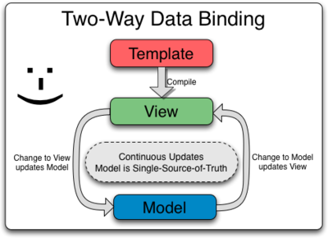

* Testing
* MVC
* Controlling the behavior of DOM elements using directives
* Flexibility provided by Filters
* Modules
* Routes

***Module***

A module is a container for different parts of your application ie. Controllers, services, directives, filters etc.

It is like a main() method in java.

They declaratively specify how the angular app should be bootstrapped

This is how you create a module :

var myApp = angular.module(“myModule”, []);

***Controller***

It’s a JS constructor function.

The job of the controller is to build a model for the view.

It does so, by attaching a model to the scope. ($scope object the we pass as the function argument while initializing the controller)

The scope object is NOT THE MODEL. The DATA that you attach to the scope is the model.

*var myApp = angular.module("myModule", []);*

*myApp.controller("myController", function($scope) {*

*$scope.message = “New mesage”;*

*}*

Here, the $scope is not the model.

The message that you’re attaching to $scope is the model.

The controller DOES NOT manipulate the view directly.

The clear separation between model, view and controller should always be maintained.

***More on 2 way data binding :***

* Binding view to model is easy
* How to bind model to view? i.e. How to update the model when the view changes
* Answer : ng-model directive
* ng-model directive can be used with
  + input
  + select
  + textarea
* See v5 for ng-model in action

***Ng-repeat:***

* Similar to foreach loop
* Can be nested
* See v6 for ng-repeat in action

***Filters***

* Can do 3 different things :
  + Format data
  + Sort data
  + Filter Data
* Can be used with a binding expression or a directive
* To apply a filter use pipe ( | )